ABC Company Logo | Company Name: ABC Iodized Salt Industry | Doc. No. OP/001 | Issue Date: June 2020
 | Title: Raw material and iodized salt storage | Issue No.1 | Page 1 of 1

TITLE | RAW MATERIAL AND IODIZD SALT STORAGE PROCEDURE
PURPOSE | - the main aim is to store the raw salt, chemicals and packaging material in sufficient place, clean and neat by preventing from physical, chemical and biological contaminants
PROCEDURE | - shall be neat and clean  - store the salt out of direct light  - shall be free from entry of rodents, pest and other biological organisms  - Shall be well conditioned or ventilated and enough lights for the storage of salt. Also there shall be wire-mesh in the walls for natural ventilation  - shall be pallet or baskets or crates for the storage of the salt  - First In First Out (FIFO) shall be in place  - The raw salt shall be stored minimum 50 cm from wall and roof  - There shall not be any cracks, leakages and related defects which can pose product contamination  - shall be built from the material that prevent the product quality and safety  - shall be far from the external contaminants (dust, chemicals and others)  - shall be sufficient for the salt to be stored  - walls and floors shall be easily cleanable  - the bin and stock cards shall be prepared and recorded  - the raw salt, chemicals and packaging material shall be separately stored

ABC Company Logo | Company Name: ABC Iodized Salt Industry | Doc. No. OP/003 | Issue Date: June 2020
 | Title: Raw Material Receiving Procedure | Issue No.1 | Page 1 of 1

TITLE | RAW MATERIAL RECIEVING PROCEDURE
PURPOSE | - The main aim is to ensure that the raw and packaging material complies
PROCEDURES | - There shall be raw material receiving procedure  - The raw material shall be checked for the compliance of requirements  - The raw materials shall be supplied from approved sources (certificate of competence and certificate of analysis)  - Check that the delivery vehicle is clean.  - Ensure that chemicals have been stored separately from food and food containers on the vehicle  - Check that there is no physical damage or spillage of chemical before receiving  - Do not accept food that is spoiled, damaged, or past its best before date.

ABC Company Logo | Company Name: ABC Iodized Salt Industry | Doc. No. OP/004 | Issue Date: June 2020
 | Title: Personnel Hygiene Procedure | Issue No.1 | Page 1 of 2

TITLE | PERSONEL HYGINE PROCEDURE
PURPOSE | - the aim is to prevent contamination of salt during storage and processing
PROCEDURES | - Train employees using the procedures in this SOP.  - Wash and dry your hands thoroughly before, during and after processing using soap or detergent  - dry your hands with a clean towel, disposable paper towel or under an air dryer  - never smoke, chew gum, spit, drink eat in a food processing or storage  - never cough or sneeze over food, or using a handkerchief or tissue where food is being processed or stored  - wear clean protective devices like head cover, gloves, dust mask, coat, shoes and others  - keep your spare clothes and other personal items (including mobile phones) away from where food is stored and prepared  - keep fingernails short so they are easy to clean, and don’t wear nail polish  - avoid wearing jewellery, or only wear plain-banded rings and sleeper earrings  - Post hand washing signs or posters in a language understood by all employees near all hand washing sinks, in food processing areas, and restrooms.  - Use designated hand washing sinks for hand washing only.  - Keep hand-washing sinks accessible anytime employees are present.

ABC Company Logo | Company Name: ABC Iodized Salt Industry | Doc. No. OP/004 | Issue Date: June 2020
 | Title: Personnel Hygiene Procedure | Issue No.1 | Page 2 of 2

PICTORIAL PRESENTATION OF HAND WASHING STEPS
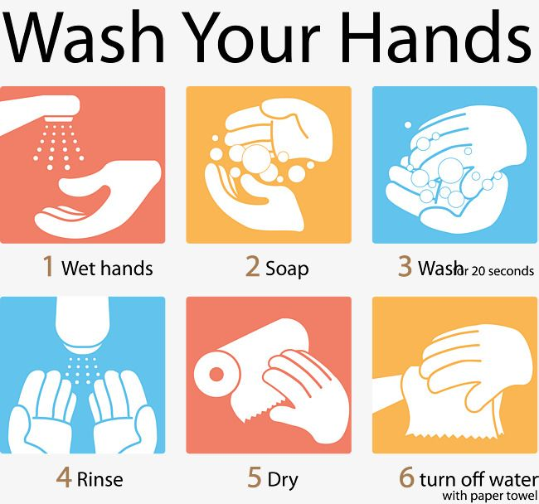
ABC Company Logo | Company Name: ABC Iodized Salt Industry | Doc. No. OP/005 | Issue Date: June 2020
 | Title: Personnel Health Checkup Procedure | Issue No.1 | Page 1 of 1

TITLE | PERSONEL HEALTH CHECKUP PROCEDURE
PURPOSE | - The purpose is to ensure that the employees working in the industry are free from food borne communicable diseases and fit for the position.
PROCEDURES | - The health employees shall be checked for food based and related food borne communicable diseases at pre-employment time  - The health of employee shall be checked at least every six months after employment.  - The personnel’s working the industry shall wear personnel protective device. And their hygiene and sanitation shall be checked regularly.  - Advise your supervisor if you feel unwell, and don’t handle food. The diseased or infected or wounded person shall be given rest or detained till become relived (healthy)  - completely cover cuts and wounds with a wound strip or bandage (brightly colored waterproof bandages are recommended)  - The industry or company can make an agreement from health institution or hospital or clinic to check the employees’ health status.  - Personnel safety, health and sanitation shall be given.

ABC Company Logo | Company Name: ABC Iodized Salt Industry | Doc. No. OP/006 | Issue Date: June 2020
 | Title: First Aid Kit Standard Operating Procedure | Issue No.1 | Page 1 of 1

TITLE | FIRST AID KIT PROCEDURE
PURPOSE | - The main aim is to give first hand treatment for emergency accidents
PROCEDURES | - Flush the burned area with cool running water for several minutes. Do not use ice.  - Apply the alcohol for the wounds or cut and cover with bandage  - Apply a light gauze bandage.  - Do not apply ointments, butter, or oily remedies to the burn.  - Do not break any blisters that may have formed.  - Do not use expired alcohol or other anti-biotic  - Take in the health facility for further treatment in clinic or health care centers or hospital

ABC Company Logo | Company Name: ABC Iodized Salt Industry | Doc. No. OP/007 | Issue Date: June 2020
 | Title: Personnel Training SOP | Issue No.1 | Page 1 of 1

TITLE | PERSONNEL TRAINING PROCEDURE
PURPOSE | - The main aim is to ensure that the employees working in the industry are well aware about the process conducted
PROCEDURES | - Provide the necessary new hire training and orientation (communicate your mission, vision, values, and goals) to new Employee  - The employees shall be well trained about the processing, quality and safety control.  - The employees shall be aware on how to use and dispose personal protective devices.  - The responsible personnel’s shall be well trained on how to use the fire extinguisher and first aid kits  - The personnel’s shall be informed about emergency situations and actions.  - Training on personnel’s health, hygiene and sanitation shall be given.  - The shall be regular schedule for the training of employees (fresh and already employed staff members)  - Assess the knowledge and skill gap of employees and deliver the training based on needs/gaps.

ABC Company Logo | Company Name: ABC Iodized Salt Industry | Doc. No. OP/008 | Issue Date: June 2020
 | Title: Fire Extinguisher Operating Procedure | Issue No.1 | Page 1 of 1

TITLE | FIRE EXTINGUSHER OPERATING PROCEDURE
PURPOSE | - The main aim is to handle the fire accidents happen the processing industry
PROCEDURES | - Key personnel’s shall be well trained about use of Fire extinguishers  - The following steps should be followed when responding to incipient stage fire:  - Sound the fire alarm and call the fire department, if appropriate.  - Identify a safe evacuation path before approaching the fire. Do not allow the fire, heat, or smoke to come between you and your evacuation path.  - Discharge the extinguisher within its effective range using four-step PASS technique.  - Pull: Pull the pin, this will break the tamper seal.  - Aim: Aim low, pointing the nozzle or hose at the base of the fire. Do not touch the horn on a CO₂ extinguisher, it gets very cold and can damage the skin.  - Squeeze: Squeeze the handle to release the extinguishing agent.  - Sweep: Sweep from side to side at the base of the fire, the fuel source, until the fire is out.  - Back away from an extinguished fire in case it flames up again.  - Evacuate immediately if the extinguisher is empty and the fire is not out.  - Evacuate immediately if the fire progresses beyond the incipient stage.

ABC Company Logo | Company Name: ABC Iodized Salt Industry | Doc. No. OP/008 | Issue Date: June 2020
 | Title: Fire Extinguisher Operating Procedure | Issue No.1 | Page 2 of 2

PICTORIAL PRESENTATION OF THE FIRE EXTINGUISHER
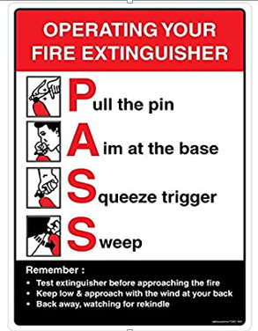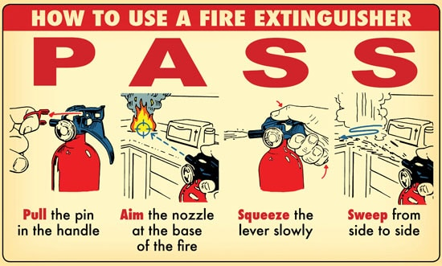
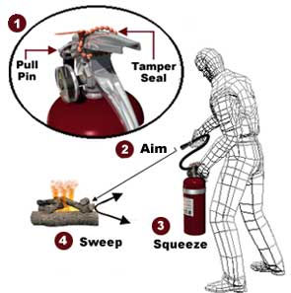
ABC Company Logo | Company Name: ABC Iodized Salt Industry | Doc. No. OP/009 | Issue Date: June 2020
 | Title: Pest Control Procedure | Issue No.1 | Page 1 of 1

TITLE |  | PEST CONTROL PROCEDURE
PURPOSE |  | - The aim is to prevent the processing and storage room from the biological contaminants
PROCEDURES |  | Procedure: employees will use the services of an integrated pest management program (IPM) using the following steps:  Deny access to pests  - Use certified and reputable suppliers and check the deliveries or raw materials  - Keep all exterior openings closed tightly. Check doors for proper fit as part of the regular cleaning schedule.  - Report any signs of pests to the responsible technical personnel or manager.  - Report any openings, cracks, broken seals, or other opportunities for pest infestation to the floor manager  Deny pests food, water, and a hiding or nesting place  - Dispose of garbage quickly and correctly. Keep garbage containers clean, in good condition, and tightly covered in all areas (indoor and outdoor). Clean up spills around garbage containers immediately.  - Store recyclables in clean, pest-proof containers  - Keep all food and supplies with pallets and 50 cm away from walls.  - Use FIFO (First In First Out) inventory rotation, so pests do not have time to settle  - Clean the facility thoroughly and regularly.  - Dispose of empty containers according to manufacturers’ directions  - Keep a copy of the corresponding Material Safety Data Sheets (MSDS)
ABC Company Logo | Company Name: ABC Iodized Salt Industry |  | Doc. No. OP/010 | Issue Date: June 2020
 | Title: Product Recall and Withdraw Procedure |  | Issue No.1 | Page 1 of 1

TITLE | PRODUCT RECALL AND WITHDRAW PROCEDURE
PURPOSE | - The main aim is to create awareness of iodized salt processing and control parameters
PROCEDURES | - prepare recalling and withdrawal procedure and recording format for defective products from process or market  - Review the food recall notice and specific instructions that have been identified in the notice.  - Communicate the food recall notice responsible departments.  - Hold the recalled product physically segregate the product and retain till the decision is made  - Mark recalled product “Do Not Use” and “Do Not Discard.” Inform the entire staff not to use the product.  - Investigate the root, basic and underline causes  - Obtain accurate inventory counts of the recalled products  - Identify and record whether any of the product was received in the district, locate the food recall product by feeding site, and verify that the food items bear the product identification code(s) and production date(s) listed in the recall notice.  - Account for all recalled product by verifying inventory counts against records  - Is there a criteria for reprocessing the non-conforming products or to be rejected and removed  - Is there a corrective action procedure to correct the non-conformity and prevent a recurrence

ABC Company Logo | Company Name: ABC Iodized Salt Industry | Doc. No. OP/011 | Issue Date: June 2020
 | Title: Distribution Standard Operating Procedure | Issue No.1 | Page 1 of 1

TITLE | DISTRIBUTION STANDARD OPRATING PROCEDURE
PURPOSE | The main aim is to distribute the iodized salt to the consumers.
PROCEDURE | - Select the approved or certified distributors of the food products  - The iodized salt industry shall prepare the vendor (distributors) list for distribution  - The factory shall deliver training about transportation, handling and storage and distribution practice of iodized salt.  - Appropriate transportation vehicles shall be in-place for iodized salt.  - Iodized salt shall be distributed in such a way that prevents the loss of iodine.  - The selling quantity and other information’s shall be well recorded  - The information of vendors selling and distribution list shall be retained at least for 1 year.  - The warehouse shall be appropriate for the storage of iodized salt.  - The distributor shall have appropriate sales and distribution channel for traceability. Moreover, the distributor shall have appropriate records for sales and distribution

ABC Company Logo | Company Name: ABC Iodized Salt Industry | Doc. No. OP/012 | Issue Date: June 2020
 | Title: Compliant Handling Procedure | Issue No.1 | Page 1 of 1

TITLE | COMLIANT HANDLING PROCEDURE
PURPOSE | The aim is for reassuring customers that you value their feedback and you are committed to resolving their issues in a fair, timely and efficient manner
PROCEDURES | - Listen to the compliant: thank the customer for bringing the matter to your attention. Apologies and accept ownership, don’t blame others and remain courteous  - Record details of the complaint: go through the complaint in detail so you can understand exactly what the problem is. Keep records of all complaints in one central place or register. It also help to identify any trends or issues.  - Get all the facts: check that you have understood and recorded the details of the complaint correctly. Ask questions if necessary.  - Discuss options for fixing the problem: ask the customer what response they are seeking; it could be a repair, replacement, refund or apology. Decide if the request is reasonable.  - Act quickly: aim to resolve the complaint quickly. If you take a long time they tend to escalate.  - Keep your promises: keep the customer informed if there are any delays in resolving their request. Don’t promise things that you can’t deliver.  - Follow up: contact the customer to find out if they were satisfied with how their complaint was handled. Let them know what you are doing to avoid the problem in the future.  - Make sure your staff trained to follow your procedure when handling complaints and that they have the power to resolve issues as quickly as possible  - Encourage your customers to provide feedback and complaints so that they let you know when there is a problem and give you the opportunity to resolve it.

ABC  Company Logo | Company Name: ABC Iodized Salt Industry | Doc. No. OP/013 | Issue Date: June 2020
 | Title: Waste Management Procedure | Issue No.1 | Page 1 of 2

Title | WASTE MANAGEMENT PROCEDURE
Purpose | This procedure is to ensure that wastes from offices and factory are managed in a way that facilitates recycling and cause no environmental pollution.
Introduction | Wastes are any leftover from offices, gardening of compound and production activities. Generated liquid or solid waste should be managed properly to protect environment. The waste management procedure enables the company to meet local and national regulations on waste management.
Scope | This procedure applies to all waste management activities within the company.
Procedure | - Training of workers is done by sanitation officer in cooperation with Production Manager regularly twice a year and whenever new workers are hired.  - Adequate bins shall be positioned around the office. Limited general waste bins shall be placed in the office, not at each employee’s desk.  - In the office, each waste stream is collected in a separate bin with clear signs referring type of waste  - All waste type from factory should be handled separately based on their disposable or reuse property (e.g. salt spillages, glass, paper, salt, packaging material etc.)  - Cleaners shall empty all bins in the office daily, and place segregated waste to waste collection area.  - Cleaners shall take care of collected waste according to property

ABC  Company Logo | Company Name: ABC Iodized Salt Industry | Doc. No. OP/013 | Issue Date: June 2020
 | Title: Waste Management Procedure | Issue No.1 | Page 2 of 2

Potential Wastes  (Solid and Liquid) | Salt from pond and factory, defective packaging material, paper, glasses, food leftovers, toilet wastes and others
Management System | - Salt from pond; sell as animal feed  - Salt from factory; recycled to brine pond  - Defective packaging from packing; incinerate  - Paper waste from office; incinerate  - Gypsum and other solid waste from brine pond: land fill  - Food waste cafeteria ; goes to land fill  - Brine from brine pond; diluted with water and released to sewerage line.  - Toilet wastes and other plastic and glass and other materials that cannot be easily removed will be take care off by the city municipal or any other responsible office will remove the waste every 3 -6 months
Responsible Person | Production Manager/Quality Manager/Sanitation Officer

ABC  Company Logo | Company Name: ABC Iodized Salt Industry | Doc. No. OP/014 | Issue Date: June 2020
 | Title: Maintenance Procedure | Issue No.1 | Page 1 of 1

TITLE | MAINTENANCE PROCEDURE
Purpose | The main aim is to maintain the process environment to optimize production and minimize food safety risk and equipment failures
Procedure | - Take inventory of equipment and access the risk: check what you have, how much you have, and what you need. At the same time, assess the risk that each equipment poses. Different types of equipment pose different hazards and you must understand how to maintain each of them properly.  - Set a schedule and optimize timing: follow the manufacturer’s guide on how to maintain different equipment and you won’t face too many maintenance issues. You must also consider how maintenance will fit into your operational schedule in the best manner possible.  - Document every procedure: apart from executing maintenance tasks efficiently, you must document all the procedures diligently. Every document must contain detailed descriptions of how each machine must be maintained and serviced.  - Assign the responsible person (maintenance head): make someone accountable and responsible for conducting all the maintenance programs.  - Keep supplies handy: you need tools to service and maintain various equipment. These specific tools may include spare parts, various types of lubricants required to service different parts of food production equipment, etc. Prioritize the supplies based on the most necessary and hardest-to find-materials to the least critical ones with the help of work order software.  - Keep detailed maintenance records. Maintain detailed records of equipment maintenance. These records act as an evidence whenever your facility is inspected or audited for safety standards. They also come in handy to understand what went wrong with an instrument, in case it breaks down suddenly.

WASTE MANAGEMENT AND DISPOSAL RECORDING FORMAT
S/N | Date | Time | SOP # | Type of Waste (Solid or liquid or plastic) | Removal Method | Done by | Signature | Remark

Checked By: __________________________________ Date: _________________________ Signature: _______________________
Approved By: _________________________________ Date: _________________________ Signature: _______________________

WASTE RECOVERY OR REUSE FORMAT
S/N | Date | Time | SOP # | Type of Waste | Recovery Standard | Done by | Signature | Remark

Checked By: __________________________________ Date: _________________________ Signature: _______________________
Approved By: _________________________________ Date: _________________________ Signature: _______________________

PRODUCT RECALL AND WITHDRAW RECORDING FORMAT
S/N | Date | Time | SOP # | Reason for recall and withdraw | Time allocated for recall & withdraw | Done by (name) | Signature | Remark

General Comment: __________________________________________________________________________________________________________________________________________________________________________________________________________________________________________________________________________________________________________________________________________________________________

Checked By: __________________________________ Date: _________________________ Signature: _______________________
Approved By: _________________________________ Date: _________________________ Signature: _______________________

MAINTENANCE RECORDING FORMAT
S/N | Date | Time | SOP # | Maintenance (Corrective or preventive maintenance | Equipment Maintained | Maintenance procedure no. | Done by (name) | Signature | Remark

General Comment: __________________________________________________________________________________________________________________________________________________________________________________________________________________________________________________________________________________________________________________________________________________________________

Checked By: __________________________________ Date: _________________________ Signature: ________________
Approved By: _________________________________ Date: _________________________ Signature: ________________

PACKAGING MATERIAL INVENTORY RECORDING FORMAT
Date | Packaging material specification meets ES |  | Packaging material In (pcs) | Packaging material out (pcs) | Number of packaging material available in Store (pcs) | Checked |  | Reviewed
 | Yes | No |  |  |  | by | Signature | by | Signature
 | ☐ | ☐
 | ☐ | ☐
 | ☐ | ☐
 | ☐ | ☐
 | ☐ | ☐
 | ☐ | ☐
 | ☐ | ☐
 | ☐ | ☐
 | ☐ | ☐

POTASSIUM IODATE INVENTORY MONITORING RECORDING FORMAT
Date | KIO₃ lot/batch number | Certificate of Analysis reference number | Store In (Kg) | Store out (Kg) | KIO₃ available in Store (Kg) | Checked |  | Reviewed |  | Remark
 |  |  |  |  |  | by | Signature | by | Signature

General Comment:
______________________________________________________________________________________________________________________________________________________________________________________________________________________________________________________________________________________________________________________________________________________________________________________________________

POTASSIUM IODATE FEEDER PERFORMANCE RECORDING FORMAT
Date | Time | Frequency Final Adjustment | Micro feeder premix level inspection | Checked |  | Reviewed |  | Remark
 |  |  |  | by | Signature | by | Signature

General Comment:
______________________________________________________________________________________________________________________________________________________________________________________________________________________________________________________________________________________________________________________________________________________________________________________________________

LABEL INSPECTION RECORDING FORMAT
Date | Enough packaging bag available for shift |  | Label on packaging material meets standard |  | Checked |  | Reviewed
 | Yes | No | Yes | No | by | Signature | by | Signature
 | ☐ | ☐ | ☐ | ☐
 | ☐ | ☐ | ☐ | ☐
 | ☐ | ☐ | ☐ | ☐
 | ☐ | ☐ | ☐ | ☐
 | ☐ | ☐ | ☐ | ☐
 | ☐ | ☐ | ☐ | ☐
 | ☐ | ☐ | ☐ | ☐

General Comment:
______________________________________________________________________________________________________________________________________________________________________________________________________________________________________________________________________________________________________________________________________________________________________________________________________

